EpiData Analysis Quick Guide
Basic mode of working:  Workflow follows this simple figure.  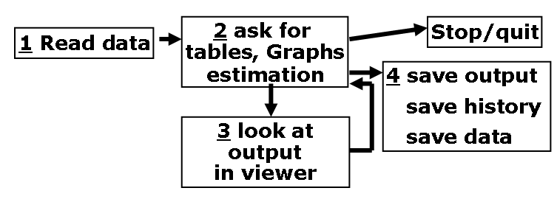  A Start the EpiData Analysis programme and compare your screen with the figure to the right. You have to press different function keys (or the window menu) to get all parts shown.  B The work-process toolbar (read..browse..graph etc) is good for beginners and has dialogs instead of commands. When you are in a dialog, for example “tables” found in “Analysis” try the different aspects and press ok. Notice that the command is then executed and added to the history,  C To repeat a command or see it again, show the history window (F7). If you click one the command is copied to the command prompt ready for editing or executed if you did a double click)..  D. The statusbar at the bottom gives information like number of observations, possible select filters, name of logfile and active folder/directory. To change folder: click or CD  E Press F1 to see precise syntax for all commands and functions. To go directly to a command in the help file: Search (ctrl+F) or write in the command prompt and press F1.  F Document data and create pgm files for reproducible work  G When output gets SLOW press F12 | 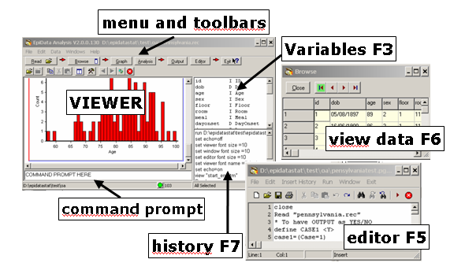
Document data with file, variable and value labels
datafile: labeldata “File v1.4 Project: Pain trial”
variable: label sex “Sex of respondent”
categories: labelvalue sex /1=”female” /2=”male”/9=”Unknown”
missing: missingvalue sex /9 // one to three values

save your datafiles: savedata “my new file” [/replace]
labels and missing are saved in “my new file.chk”

pgm file content: Insert history (all commands you executed) to the editor (F5), remove lines not desired and save as a “clean” command file (pgm), before you exit the programme.
- Continue commands on several lines by ending with: \
- Add comments in the text with a beginning: * or a later //

Then you can redo your analysis at any time, by running the pgm file. Additionaly you can send the pgm and data to someone and ask for help.

b.  [if exp] [in range]  [weight] [using...] [,options]  elements in square brackets are optional  help command or search command to get help  Double quotes around strings “myname”  Use == for logical equality (if x==1)  Use /// to continue a line greater than 80 chars  set more off, perm – lets result scroll on screen without  paging with (-more-)  cd mydir – change stata directory  Always change stata directory to your working directory  Log file  log using myfile.log – start a log file for results (in text  format)  log close – ends the log (close the log before reviewing  the contents)  cmdlog using filename.do – start saving command in  filename.do (it’s also possible to save previous commands  using right click while in the review windows)  Working with data  Read a datafile  use filename.dta – Load the filename.dta data file  clear – removes the current dataset from memory  use filename.dta,clear – Clear memory and load  Read a delimited text file  insheet using filename.txt ,comma – load the comma  separated text file  insheet using filename.txt ,tab – load the tab  separated text file  Same in/if options as dta files  Save a .dta file  save filename.dta,[replace] – save the current data file.  replace option allow overwriting.  Save a text file (for excel)  outsheet using filename.csv,comma replace  outsheet using filename.xls,tab replace  Keep and drop records  drop if case == 1  keep if case != 1  drop myvar – delete myvar from dataset  Listing  list [varlist]  list if condition – list records satisfying the condition  list in 5 – list the record number 5  list in (1/10) – list the first 10 records  list if temp >= 39.7 & temp != . – list record  where temp is >=39.7 and exclude missing values (missing  is considered as greater than everything)  [Varlist] is a variable list as :  sex age – sex and age variables  q1* – all variables starting with q1  sex-height – all of the variables including and between  sex and height (in the order of the dataset)  _all – all variables  Conditional  if x==1 – x equals 1  if x==1 & sex == 0 – x equal 1 and sex = 1  if x==1 | sex == 0 – x equal 1 or sex = 1  Do-Files  do-files are commands saved in a text files with a do  extension.  do myfile – execute all the commands of myfile.do  doedit myfile.do – edit the content of myfile.do  Comments in a do-file: // comment,  Labels  label data ”Dataset label”  label variable myvar “The variable myvar”  label define yesno 1 yes 0 no  label values myvar yesno  Sorting  sort x1  by myvar: command – does command for each group in  myvar (data must be sorted)  New var - Random data - samples  generate x = y/10  gen myvar = cond(mycondition,x,y) –if mycondition is  true then myvar = x otherwise myvar = 2  gen x=uniform()– random between 0 and 1  egen x=rank(uniform())– random from 1 to Nb of obs  sample 30 – keep 30% of the dataset  sample 30, count – keep 30 records of the dataset  sample 30 if case == 1, count  set obs 10 – create an empty dataset of 10 records if no  dataset already in memory  Recoding  replace x = x/10  recode var1 (3=1)  recode [varlist] (3=1)  recode var (1=2) (else=0)  recode var (1/5=1) (6 7 8=2)  recode var (1/5=1) (6=2), gen(var2) – recode var  and put the result in var2 (don’t modifying var)  replace var = 3 if var = . & case = 1 – replace var  by value in records satisfying the condition  replace age = d(12/10/2006) - dob  Graphs  twoway(scatter x1 x2), title(“Graph title”)  histogram(x), title(“Graph title”)  Analysis  Describe data format  describe [varlist]  Summarize data  summarize  codebook  summarize x y z ,detail – Reports means, std.  errors, etc. detail adds median, other stats  Tables  tab x  tab x ,nolabel – display values instead of labels  tab x ,miss – include missing values in table  tab x y,row chi2 – include row percentages and chi2  Epitab (variables must be coded as 0/1)  cs case protein – cohort studies  cc case protein – case-controls studies  T-test (mean comparaison)  ttest x by(y)  ttest x by (y) unequal – for unequal variance  Multivariate  regress y x1 x2 x3 – y is the dependant variable | F  a. Correct selection of current folder/directory on your disk, as indicated the bottom left part of the statusbar ?.  if not: click on statusbar left or use the command: CD  b. When speed of output is slow, clear screen: press F12  C.Put all file names and texts in “....”

